Set1:

Lab1: SQL injection vulnerability in WHERE clause allowing retrieval of hidden data

Task Completed:

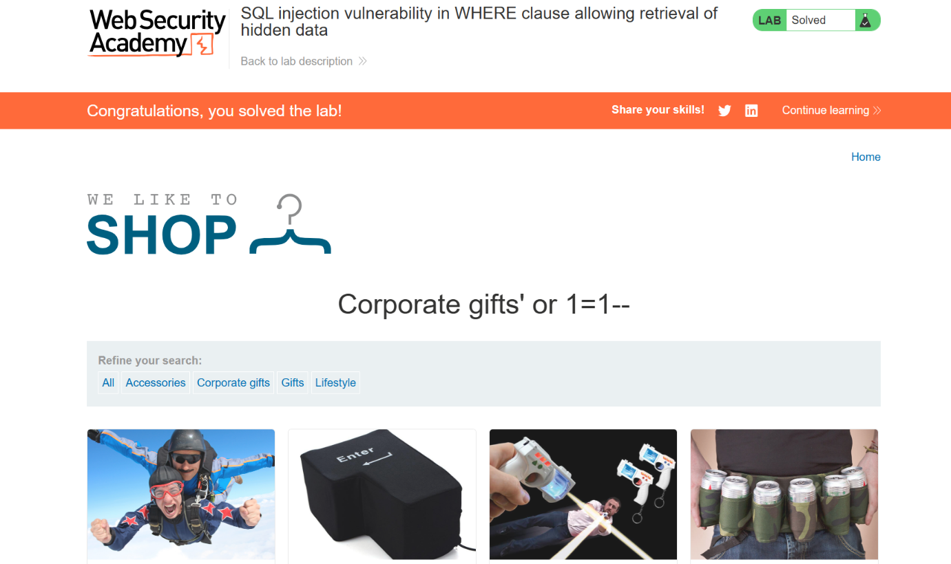

Lab2: SQL injection vulnerability allowing login bypass

Task Completed:

